## COLLEGE OF Engineering – department of computer science

Circuits 2

Name1: Reem AlSharabi

Name2: Razan Almahdi

Name3: Haneen Alzaher

*To be submitted in groups of 3 by the end of the session*

Task 1:

Implement the XOR operator using only basic logic gates (AND, OR, NOT).

To do so, draw the truth table of XOR and find the boolean expression of it. Draw the corresponding circuit.

*Include truth table, boolean expression and circuit done on circuitverse*

|  |  |  |
| --- | --- | --- |
| x | y | x XOR y |
| 0 | 0 | 0 |
| 0 | 1 | 1 |
| 1 | 0 | 1 |
| 1 | 1 | 0 |

(x’ . y) + (x . y’)

|  |  |  |  |  |  |  |
| --- | --- | --- | --- | --- | --- | --- |
| x | Y | x’ | y’ | x’ . y | x . y’ | (x’ . y) + (x . y’) |
| 0 | 0 | 1 | 1 | 0 | 0 | 0 |
| 0 | 1 | 1 | 0 | 1 | 0 | 1 |
| 1 | 0 | 0 | 1 | 0 | 1 | 1 |
| 1 | 1 | 0 | 0 | 0 | 0 | 0 |

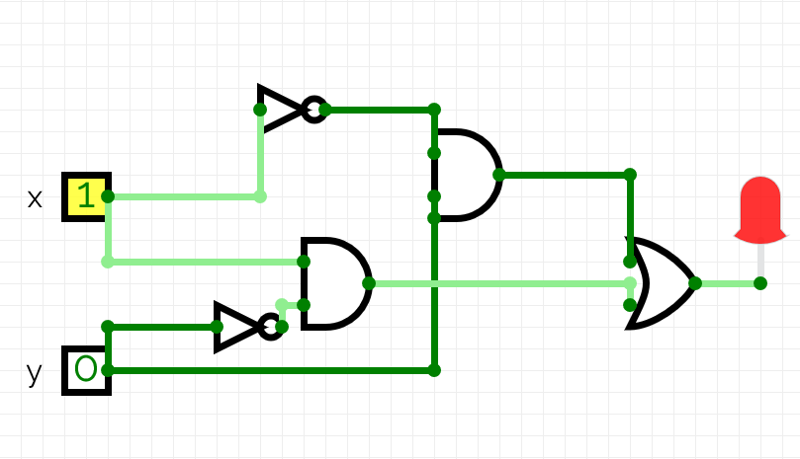

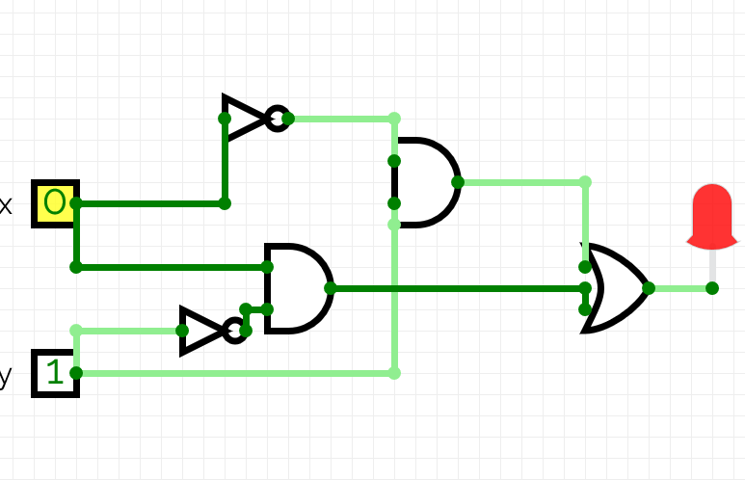

Task 2:

In this task, you will implement a 3-to-8 decoder.

A 3 to 8 decoder has three inputs (b2,b1,b0) and eight outputs (D0 to D7).

Based on the 3 inputs one of the eight outputs is selected, the input actually represents a binary number of 3 bits b2,b1,b0. The circuit is going to activate the output that corresponds to the decimal value of the inputs.

For example, when b2=b1=b0=0, D0 = 1 and all the other outputs are 0.

When b2=0,b1=0,b0=1, D1=1 and all the other outputs are 1.

When b2=1,b1=1,b0=1, D7=1 and all other outputs are 1 (cause 111 is actually 7 in decimal!)

And so on.

Find the truth table of the decoder, find the Boolean expression of each output and draw the corresponding circuit.

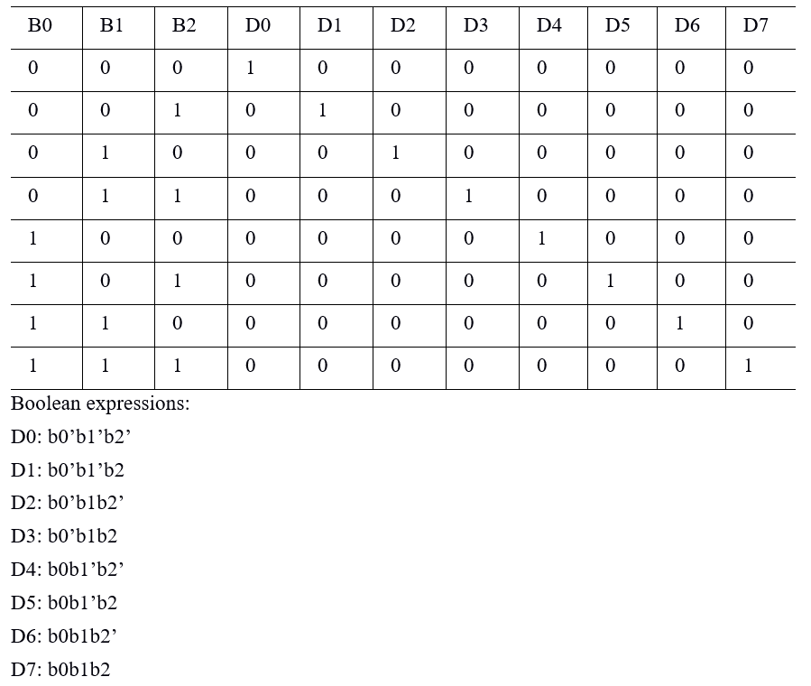

*Include truth table, Boolean expressions and circuit done on circuitverse*

Task 3:

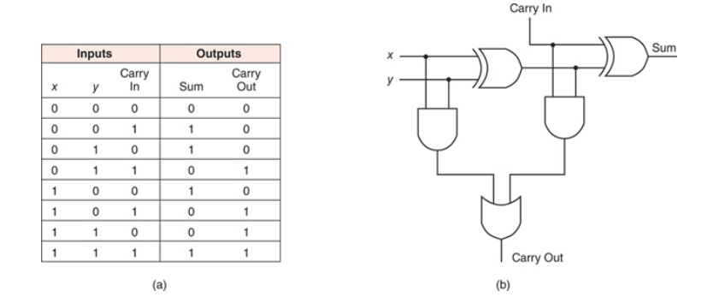Above the truth table and the circuit of a full adder. A full adder takes as inputs x, y and carry in and gives as outputs sum which represents the sum of x, y and carry in, carry out as a second output.

Based on given information, draw the circuit that adds two binary numbers of 4 bits.

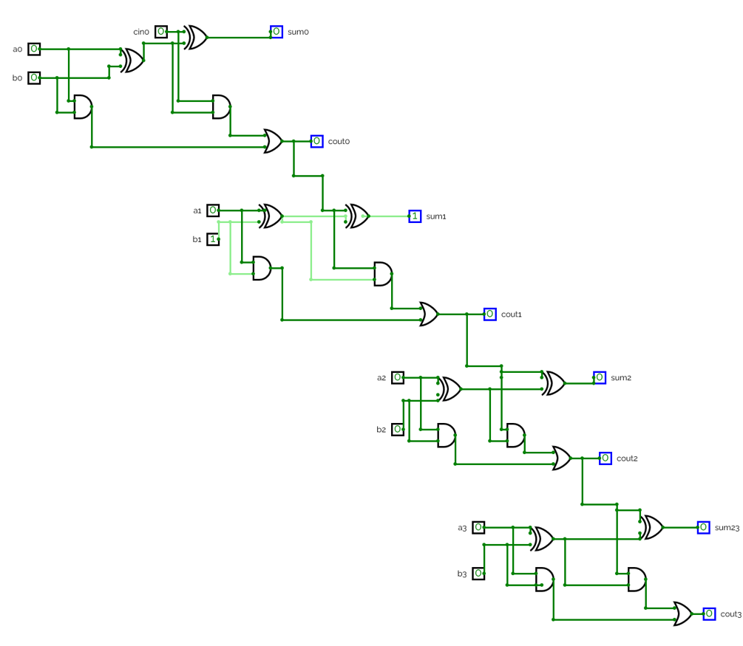

*Include circuit done on circuitverse*

Task 4:

Below the circuit of a multiplexer.

It has 6 inputs: I3, I2, I1, I0, S1, S0 and one output.

Draw the truth table of the multiplexer and explain what it is doing. Where would a multiplexer be useful?

